Additional queries
- Creation
- Insertion

- select m.ename, count(e.empno) as team_size from employee e join employee m on e.mgr_no = m.empno group by m.empno, m.ename order by team_size desc;

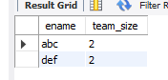

- select m.empno, m.ename, m.sal from employee m where m.empno in (select distinct mgr_no from employee) and m.sal > (select avg(e.sal) from employee e where e.mgr_no = m.empno);
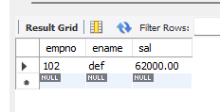

- select d.deptno, d.dname, e.empno, e.ename from employee as e join dept as d on d.deptno = e.deptno where e.mgr_no in (select empno from employee where mgr_no IS NULL) order by d.deptno, e.empno;

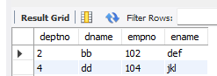

- select e.empno, e.ename, i.incentive_amount from employee e join incentives i on e.empno = i.empno where i.incentive_date between '2019-01-01' and '2019-01-31' order by i.incentive_amount desc limit 1 offset 1;

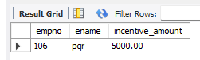

- insert into employee values(107,'stu',101,'2019-01-02',25000,01);
select e.empno, e.ename, e.deptno from employee e join employee m on m.empno = e.mgr_no where e.deptno = m.deptno;
